**VALMIKI**

Maharishi Valmiki (the great sage) claims the distinction of being the author of the holy epic 'Ramayana', consisting of 24,000 verses. He is also believed to be the author of Yoga Vasistha, a text that elaborates on a range of philosophical issues. There are different versions regarding the time period and life of Valmiki. The Valmiki Ramayana is believed to be dated variously from the period 500 BC to 100BC. But at the same time Valmiki is also said to be the contemporary of Lord Rama. Sita took refuge in her Ashram where Lava and Kusa were born. Against this backdrop, the period of Valmiki is likely to date back to thousand of years.

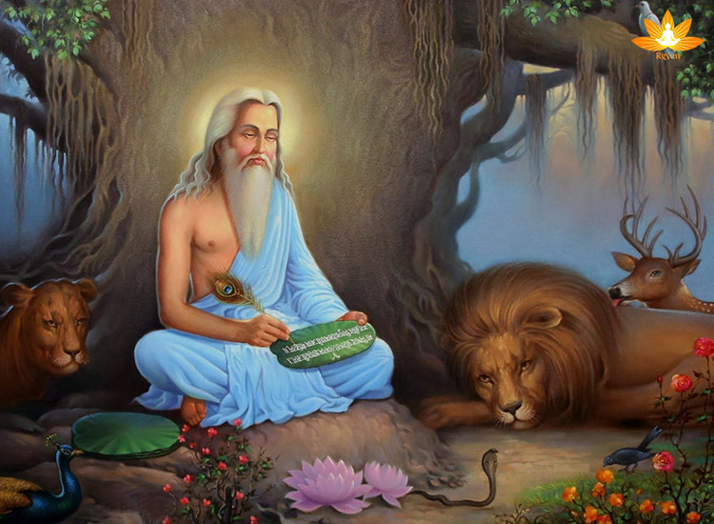

There is much controversy regarding the life of Maharishi Valmiki. But a judgement given by Justice Rajive Bhalla of the Punjab and Haryana High Court in the year 2010 could change an age-old belief about Maharsihi Valmiki.

British satirist Aubrey Menen says that Valmiki was "recognized as a literary genius," and thus was considered, "an outlaw," presumably because of his "philosophic scepticism," as part of an "Indian Enlightenment" period. Valmiki is also quoted as being the contemporary of Rama. Menen claims Valmiki is "the first author in all history to bring himself into his own composition."

**Early life**

The boy born to sage Prachetasa was given the name Ratnakara by his parents. It is said that when Ratnakara was a few years old, he wandered into a forest and got lost. The young boy was found by a hunter who adopted and raised him. Under his foster father's guidance, Ratnakara also grew up to become an accomplished hunter.

When Ratnakara reached marriageable age, he was married to a girl from the hunter’s family. With time, Ratnakara's family also increased in number and he became a father to many children. The expansion of his family meant it became difficult for hunter Ratnakara to make ends meet. As a result, out of desperation, he took to robbery and began looting travellers who passed by his area.

**The journey of Ratnakara into Valmiki**

Though born in to a brahmin family, Ratnakar had turned bandit by with bad of others. He used to loot the people who would travel through the lonely paths of wood. One day, Narada Munni was crossing by the wood where Ratnakar used to reside and loot When he saw Narada, he challenged Narada to stop. Unafraid by him, Narada turned to him and said, Look brother, I do not possess anything that you would like to take. Why are you engage in killing innocent There is no sin greater than killing another fellow-mate. And for whom you are committing such heinous crime ?

Ratnakar was accustomed to watching frightened faces that used to cry and beg for his mercy. Ratnakar was astonished to see Narada, he was not bit afraid and moreover had the courage to question him. He was by Narada and answered, to feed my large family, I loot and take their wealth. Narada replied: Brother, go and ask them if they are willing to share your sins for whom you are committing these sinful actions. And don't think that I would run away, if you don't believe me then you an tie me with this rope to the tree.

Ratnakar after tying Narad with the went to his home and asked everybody the same question: Is anybody ready to share my sins?" The same reply came from each of his family: It is your duty to look after me, to feed us. It is not my concern as to by which method you earn wealth, so why should I share your sins? " Ratnakar was disillusioned. He who was toiling, committing sins, taking risks, day and night for them and here they were not even ready to share his sins. He saw the futility of his actions he had committing. Ratnakar went back to the forest and untying Narada fell at his feet and started crying and said: O learned man, how can a mean person like me achieve salvation?

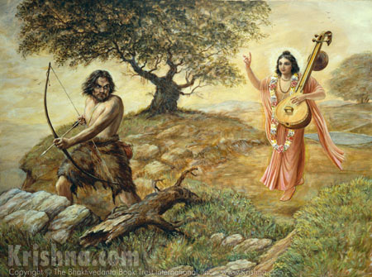

Narada after thinking for a while asked him to chant the name of God Rama but for Ratnakar even pronouncing it was difficult. When Narada saw that even after trying very hard, Ratnakar was not successful in his to chant Rama's name, he asked him to pronounce it backwards that is 'Mara ' and then Narada went away. Ratnakar started to chant 'Mara, Mara' sitting there. He continued with this chant for 4 days, months, years and even Yuga! He did not get up for a single moment, even opened his eyes. His body was so still that termites made his body their home and his whole body was covered with them. Lord Brahma after being by his penance blessed him and gave him the name Valmiki, since he was reborn from the Valmika (the ant-hill).

**Story behind Becoming the first poet**

One day, Devamuni Narada was conversing with sage Valmiki and happened to tell him the story of Maryada Purushottam Rama, describing Rama’s many qualities, including truthfulness, bravery, self-competence, and wisdom.

After Narada left, Valmiki went to the Tamasa river for his mid-day baths, where he spotted two crane birds calling to each other and mating. Valmiki was filled with joy seeing the happy birds. Suddenly, an arrow pierced the body of the male bird, killing him immediately. Filled with sorrow, his mate died of shock. Upon seeing this, the enraged rishi could not 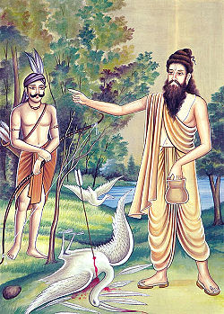control himself and cursed the hunter.

Although he was grief-stricken and in a lot of pain over the death of the innocent creatures, he couldn’t help but notice that the curse he uttered came out in a musical form that could be recited or sung. He narrated the entire incident to his disciple Bhardwaja, who memorised the couplet uttered by the sage while in grief. This then became the first-ever shloka in Sanskrit literature.

The sage continued to brood over the incident, until, one day, Brahma appeared before him and asked him to get over his grief. He inspired the guru to compose the story of Rama in the same poetic meter in which he had cursed the hunter.

To do this, Brahma bestowed on him the divine power to see all that happened, even the thoughts of the characters. With these divine powers, he was able to see the entire life of Rama, the past, the present, and the future. Thus, Valmiki composed one of the longest works of literature the world has ever known, the epic that came to be called the Ramayana, comprising 24,000 verses across seven kandas, divided into 500 saragas.

**Story of Ramayana by Valmiki**

Once upon a time, while the sage Valmiki was performing austerities on the back of the river Tamasa, Narada Muni appeared before him and narrated a summary of the Ramayana, called the "Mula-ramayana" or the Original Ramayana. After hearting the mula-ramayana, the sage Valmiki composed thousands of Sanskrit verses to elaborately narrate all then incidents in this great epic.

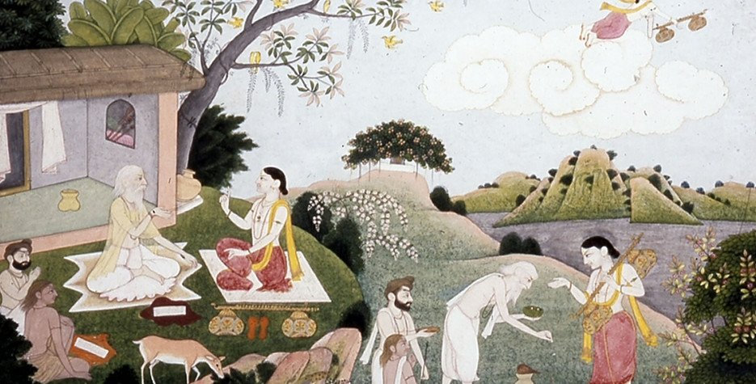

In the opening chapter, while eulogizing [to speak or write in high praise of] Rama, Narada gives an outline of Ramayana, truly highlighting those aspects that are the keynotes in this epic, like virtuosity, generosity, morality, chastity and the like.In the first chapter of Bala Kanda the gist [the main points] of Ramayana is imbibed [absorbed] and it called samkshepa [summarized] Ramayana, or also called Bala Ramayana. The Youngsters are asked to recite these stanzas daily for longevity and a perfect personality like that of Rama.

Valmiki Ramayana is said to have been composed basing on each of the twenty-four letters of Gayatri Hymn, and a thousand verses are arranged into one book under the caption of each letter.

**Story behind the last part -Uttarkanda**

Lord Brahma blessed sage Valmiki, by the power of which he was able to pen down the exploits of Sri Rama through his own work. This work was to qualify as the very backbone of Shastras, the repository of knowledge within Sanatana Dharma. He took up the initiative to expand the 32 verses of sage Narada into 24,000 verses to form the entire body of work called the Valmiki Ramayana. The 32 verses of Sri Narada is popularly known as Sankshepa Ramayana (Oq OIT4UT). By the blessing of Sri Brahma, Sage Valmiki attained the ability to expand the 32 verses into 24000 verses.

Kandas had already passed by. At the time when he was still composing the verses, the 7th Kanda named Uttara Kanda was underway when Srimati Seeta Devi had taken shelter in the Valmiki Ashram following which the sons of Sri Rama Luv and Kush were born in the Ashram. As the princes Luv and Kush grew up in Ashram, Sage Valmiki consummated the final Uttara Kanda of the Ramayana. It was during this time that Sri Rama had set up a camp at Naimasharanya to hold the Ashvamedha Yajna. Under these circumstances, by the arrangement of Providence the two princes Luv and Kush dressed in the attire of renunciant brahmacharis sang the Ramayana of Sage Valmiki in front of Sri Rama and His entourage. Sri Rama was so impressed by the rendition of the two princes that He expressed

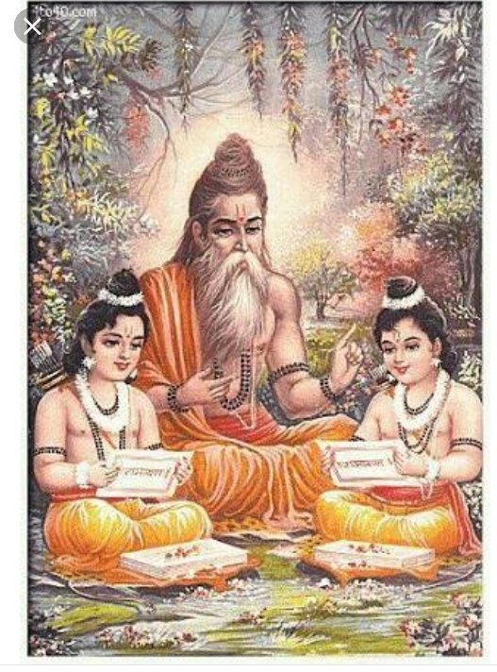His great desire to meet the spiritual master of the two children. He sent Bharata to the Ashram of Sage Valmiki, to invite the sage for a meeting with the Lord. Sage Valmiki, along with Srimati Seeta Devi went to meet the Lord along with Bharata. The twins Luv and Kush were already at the camp with the Lord when sage Valmiki arrived along with Srimati Seeta Devi.

The event of Srimati Devi being consumed by Bhumi Devi, the Earth as well of ascension of Sri Rama to Sri Vaikuntha was already included in the Ramayana poem that Luv and Kush recited before the Lord. Sage Valmiki is Trikala darshi, the knower of past, present and future.

He had composed the Ramayana by the grace of Sri Brahma. Thus 6 Kandas had already manifested and the 7th Kanda was about to manifest at the time of the first rendition of the Ramayana.

**Tulsidas as the reincarnation of Valmiki**

It is mentioned in Bhavishya Purana, that Lord Shiva told Goddess Parvathy that Valmiki would take birth as Tulsidas in Kali Yuga. Valmiki was blessed by Hanuman that he would sing the glory of Lord Rama in vernacular language and for that, he would incarnate in Kali 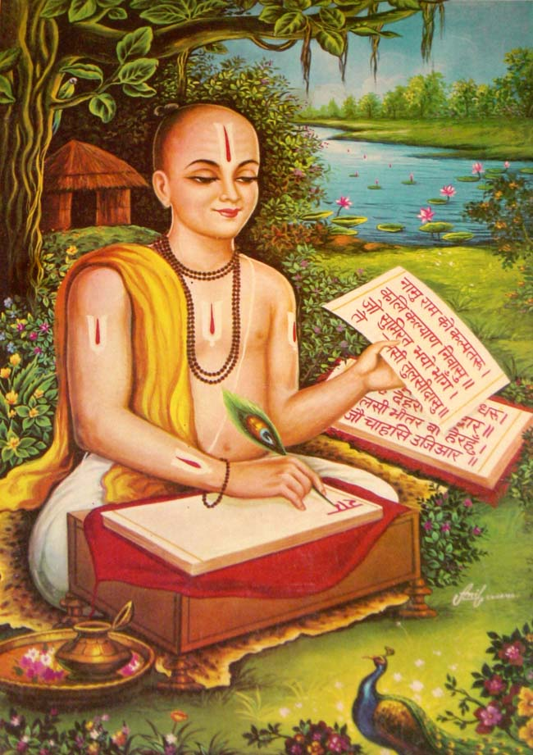Yuga.We know that Valmiki wrote Ramayana in Sanskrit.

There is even a story behind this. Lord Hanuman wanted to hear Ramayana from the mouth of Valmiki but was turned down by Valmiki because he was a monkey. Hanuman after the destruction of Ravana, went to the Himalayas and wrote Rama Katha by engraving the scenes on rocks. Valmiki felt that Hanuman’s narration could supersede his Ramayana. Understanding this, Hanuman threw the engraved rocks into the ocean but instructed Valmiki to be reborn as Tulsidas and write Ramakatha in his vernacular language Awadhi.

**Temples associated with sage Valmiki**

There is a small temple or a Jeeva Samadhi for Saint Valmiki in Thiruvanmiyur, Chennai. Interestingly, Thiruvanmiyur the name of the place, itself is derived from Thiru-Valmiki-Oor. One of the 18 Siddhas of TamilNadu is Vanmeegar. Some say he is same as Valmiki who wrote Ramayana.

This temple is nearby the famous Marundeeswarar Shiva Temple. As you can see from the image below, Valmiki temple is in the middle of the road and the highways department wanted to remove it. But it was stopped due to protests from various people. A few years ago, it was by the side of the road. A few decades ago, this was a part of the Marundeeswarar temple land.

Another temple associated with Sage Valmiki is that of Kuchalavapureeshwarar Siva temple in Koyambedu, Chennai. It is said that the ashram of sage Valmiki was located here and the sons of Lord Rama - Kucha and Lava performed Pujas here.

Another temple for Valmiki is located at Tirupathur in Sivaganga District in TamilNadu. It is said that Sage Valmiki did tapas at this place.

Maharishi Valmiki is considered as one of the main Gurus of the Valmiki(Balmiki) sect. Maharishi Valmiki Jayanthi is celebrated with fervour in most parts of north India and there are several mandirs for him in the north.